

**COMSATS University Islamabad (Lahore Campus)**

**<Lab Task 3> – SPRING 2024**

|  |  |  |  |  |  |
| --- | --- | --- | --- | --- | --- |
| Course Title: | Game Development | Course Code: | CSC495 | Credit Hours: | 3 |
| Course Instructor/s: | Saira Aslam | Program | BSE | | |
| **Submission Deadline** | **11:55 pm, 20-3-2024** | **Maximum Marks:** | **50** | | |
| **Important Instructions / Guidelines:**   * Submit a 10 seconds video, 4 screenshots, and all your scripts in Lab Assignment 1 submission at google classroom * Paste your screenshots and scripts inside Lab Assignment-1 submission file provided | | | | | |

***Question No 1.***

***CLO: <3>; Bloom Taxonomy Level: <****Apply****>* [80]**

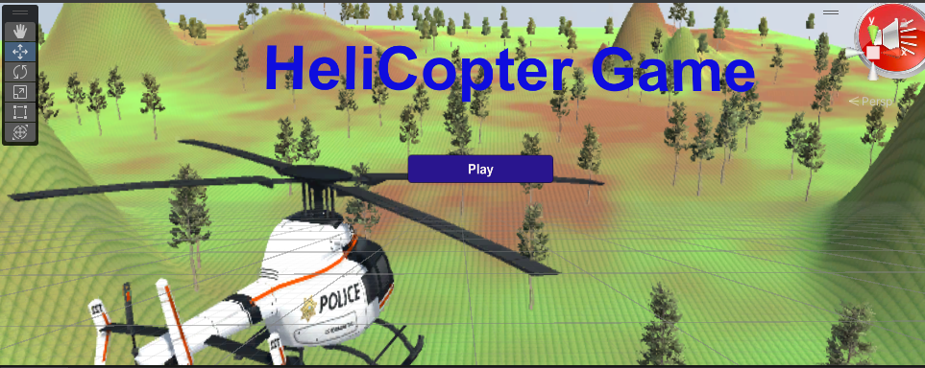

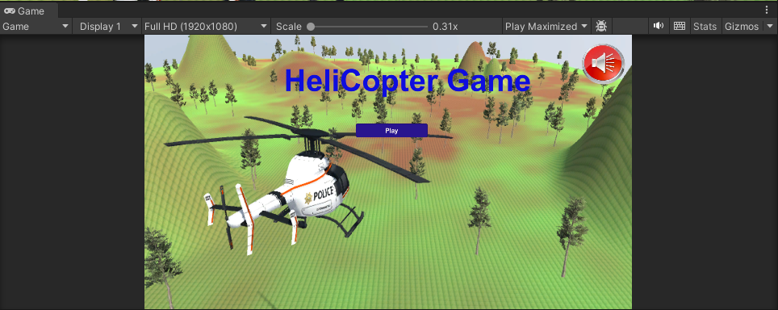

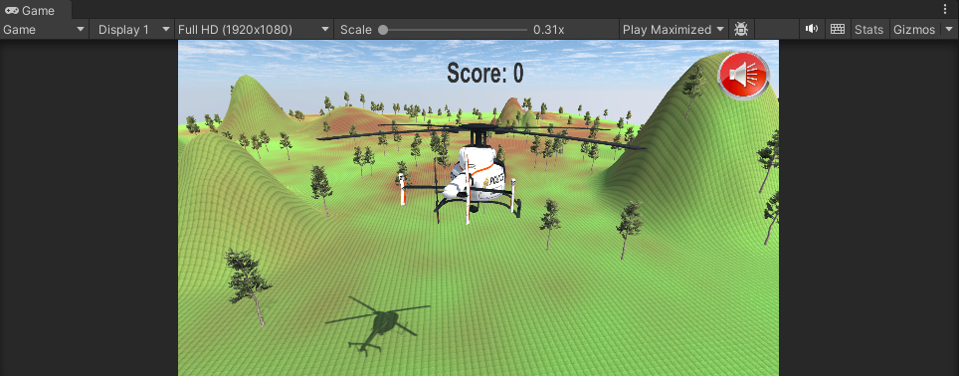

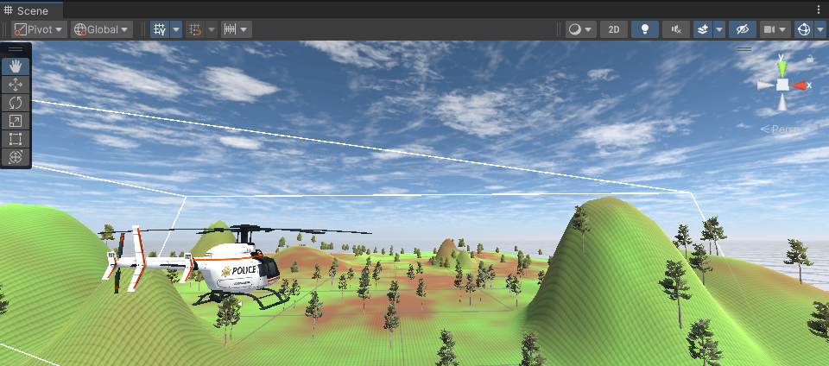

**bulletScript.cs**

using System.Collections;

using System.Collections.Generic;

using UnityEngine;

public class bulletScript : MonoBehaviour

{

    public GameObject explosion;

    [SerializeField]

    public static bool collided = false;

    // Start is called before the first frame update

    void Start()

    {

    }

    // Update is called once per frame

    void Update()

    {

        transform.Translate(0,0,1);

    }

    public void OnCollisionEnter(Collision col)

    {

        if(col.gameObject.name.StartsWith("Enemy"))

        {

            Destroy(col.gameObject); //destroy the enemy

            Instantiate(explosion,transform.position,transform.rotation);

            collided = true;

        }

        Destroy(transform.gameObject); //destroy bullet clone

    }

}

**enemyScript.cs**

using System.Collections;

using System.Collections.Generic;

using UnityEngine;

public class enemyScript : MonoBehaviour

{

    public GameObject heli;

    // Start is called before the first frame update

    void Start()

    {

    }

    // Update is called once per frame

    void Update()

    {

        transform.Translate(0,0,0.8f);

        transform.LookAt(heli.transform);

    }

}

**helicopterScript.cs**

using System.Collections;

using System.Collections.Generic;

using UnityEngine;

using UnityEngine.SceneManagement;

using UnityEngine.UI;

public class hellicopterScript : MonoBehaviour

{

    public GameObject muteButton;

    public GameObject unmuteButton;

    public Text scoreText;

    public float score = 0;

    public static bool muteflag;

    public AudioSource audio;

    // public bulletScript enemy;

    public GameObject bullet;

    // Start is called before the first frame update

    void Start()

    {

        audio = GetComponent<AudioSource>();

        scoreText.text = "Score: "+score.ToString();

        if(muteflag == true)

        {

            audio.mute = true;

            muteButton.SetActive(false);

            audio.volume = 0;

        }

        else

        {

            audio.mute = false;

            unmuteButton.SetActive(false);

            audio.volume = 1;

        }

    }

    public void mutegame()

    {

        audio.mute = true;

        muteButton.SetActive(false);

        unmuteButton.SetActive(true);

        AudioListener.volume = 0;

        muteflag = true;

    }

    public void unmutegame()

    {

        if(muteflag == true)

        {

            audio.mute = false;

            muteButton.SetActive(true);

            unmuteButton.SetActive(false);

            AudioListener.volume = 1;

            muteflag = false;

        }

    }

    // Update is called once per frame

    void Update()

    {

        if(Input.GetKey(KeyCode.LeftArrow))

        {

            transform.Rotate(0,-1,0);

        }

        if(Input.GetKey(KeyCode.RightArrow))

        {

            transform.Rotate(0,1,0);

        }

        if(Input.GetKey(KeyCode.UpArrow))

        {

            transform.Translate(0,0,1);

        }

        if(Input.GetKey(KeyCode.DownArrow))

        {

            transform.Translate(0,0,-1);

        }

        if(Input.GetKey(KeyCode.W))

        {

            transform.Translate(0,1,0);

        }

        if(Input.GetKey(KeyCode.S))

        {

            transform.Translate(0,-1,0);

        }

        if(Input.GetKey(KeyCode.Space))

        {

            Instantiate(bullet,transform.position,transform.rotation);

            if(bulletScript.collided)

            {

                score += 10;

                scoreText.text = "Score: "+score.ToString();

                bulletScript.collided = false;

            }

        }

    }

    public void OnCollisionEnter(Collision col)

    {

        if(col.gameObject.name.StartsWith("Enemy"))

          SceneManager.LoadScene(0);

    }

}

**enemyLauncherScript.cs**

using System.Collections;

using System.Collections.Generic;

using UnityEngine;

public class enemyLauncherScript : MonoBehaviour

{

    public GameObject enemy;

    // Start is called before the first frame update

    void Start()

    {

        for(int i=0; i<=9; i++)

        {

            Vector3 enemyPos = new Vector3(Random.Range(10,2000),Random.Range(10,200),Random.Range(100,1500));

            Instantiate(enemy,enemyPos,transform.rotation);

        }

    }

    // Update is called once per frame

    void Update()

    {

    }

}

**audioScript.cs**

using System.Collections;

using System.Collections.Generic;

using UnityEngine;

using UnityEngine.SceneManagement;

public class audioscript : MonoBehaviour

{

    public GameObject mutebutton;

    public GameObject unmutebutton;

    public AudioSource muteaudio;

    public static bool muteflag;

    // Start is called before the first frame update

    void Start()

    {

        muteaudio = GetComponent<AudioSource>();

        if (muteflag == true)

        {

            muteaudio.mute = true;

            mutebutton.SetActive(false);

            muteaudio.volume = 0;

        }

        if (muteflag == false)

        {

            muteaudio.mute = false;

            unmutebutton.SetActive(false);

            muteaudio.volume = 1;

        }

    }

    public void mutegame()

    {

        muteaudio.mute = true;

        mutebutton.SetActive(false);

        unmutebutton.SetActive(true);

        muteflag = true;

        AudioListener.volume = 0;

    }

    public void unmutegame()

    {

        if (muteflag == true)

        {

            muteaudio.mute = false;

            mutebutton.SetActive(true);

            unmutebutton.SetActive(false);

            muteflag = false;

            AudioListener.volume = 1;

        }

    }

    public void playlevel1()

    {

        SceneManager.LoadScene(1);

    }

}